

**Finding Usable Materials**

*Developed in partnership with the University of Michigan Library Copyright Office.*

This document is a resource for faculty, staff, and students to learn where to find content they can easily use, remix, and share without worrying about copyright restrictions. Not all content that can be found online is free or available to use in your digital course materials, and so this document presents a variety of websites that host materials that are free to use either without attribution or with just a single attribution.

Much of this use is facilitated by Creative Commons licenses. To learn more about Creative Commons licenses, check out the [U-M Library Copyright Offices’ libguide on Creative Commons](https://guides.lib.umich.edu/creativecommons) and [Academic Innovations’ How to: Attributions guide](https://docs.google.com/document/d/1pKRcq2vOz_cqweR7iYmij4aArTQE8JqdqTYicWwMF80/edit?usp=sharing).

**Note:** Just because a piece of content appears in one of the resources below, does not *guarantee* it is OK to use. Always be sure to verify that the license of any content you wish to reuse is appropriate for your work.

**Photographs & Images** **2**

Pixabay 2

Unsplash 2

Openverse 3

Flickr 3

Wikimedia Commons 4

Google Image Search 4

Pexels 5

Everypixel 5

Freepik 6

Stock Up 6

Altphotos 7

**Icons & Emojis** **7**

The Noun Project 7

Twitter Emojis 8

Freepik 8

Iconmonstr 8

**Books & Textbooks** **8**

HathiTrust Digital Library 8

**Journal Articles** **8**

Directory of Open Access Journals (DOAJ) 8

**Video** **9**

Youtube 9

Vimeo 9

Mazwai 10

Pexels 10

**Audio** **10**

CC Mixter 10

Freesound 10

MusOpen 10

Free Music Archive 10

Openverse 10

**Musical Scores** **10**

International Music Score Library Project ("IMSLP") 10

Mutopia Project 11

# 

# Photographs & Images

| 📣 | If you’re interested in using images that focus on diversity, equity, inclusion, and justice, take a look at the resources listed in the [DEIJ Open Image Bank](https://docs.google.com/document/d/1VXcfZu3rHAcPThdSAN7w_vHDVoLGbHV9hih5yEsB6Fw/edit?usp=sharing). |
| --- | --- |

## 

## [Pixabay](https://pixabay.com/)

Pixabay is a large collection of photos, illustrations, and vector graphics that have all been dedicated to the Public Domain. Content from the Public Domain can be used freely and without attribution.

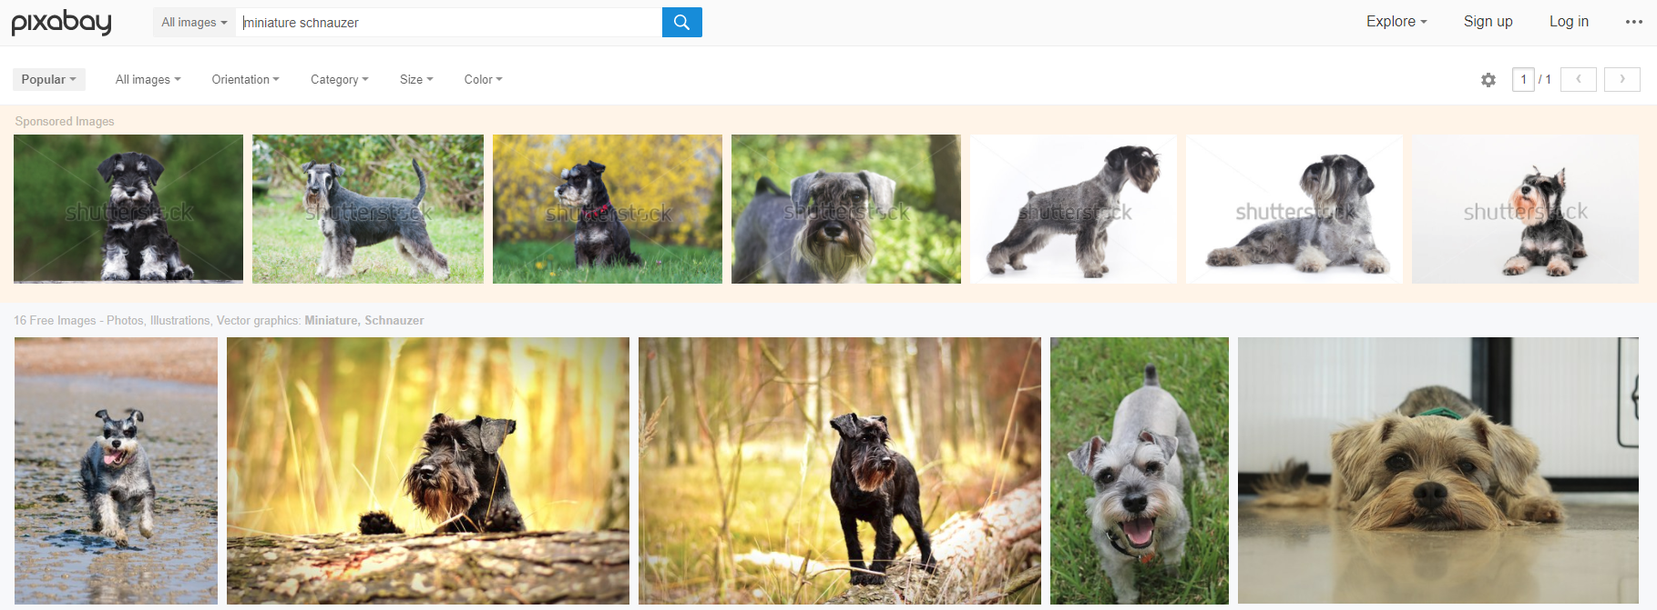

(Note: Watch out for sponsored images at the top of the search results page, which are not free to use)

## [Unsplash](https://unsplash.com/)

Unsplash is a large collection of photos that can be downloaded and used for free. They are licensed under the Unsplash License, which is similar to CC0 (Public Domain) in that it allows users to use photos for free, for personal or commercial purposes, without attribution.

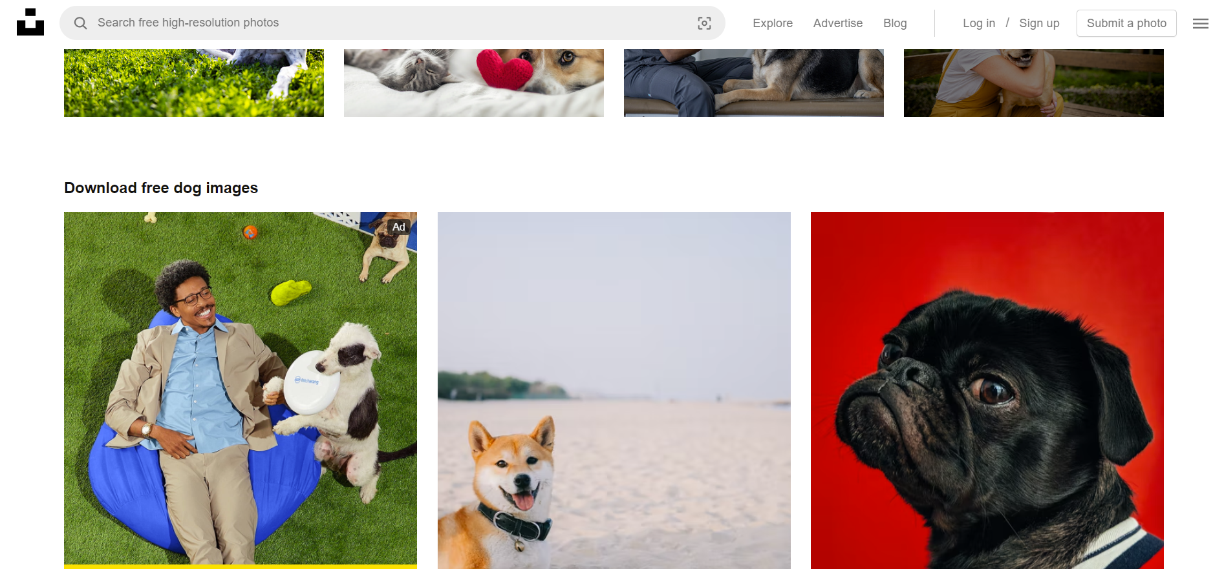

(Note: Watch out for sponsored images at the top of the search results page, which are not free to use)

## [OpenverseOpenverse](https://wordpress.org/openverse/)

This robust index searches through >600 million works from various collections. All content is licensed under CC or public domain. Convenient options exist to search for images or audio, and filter options enable granular selection of only particular types of licenses as needed (such as only CC BY-SA works). Because Openverse indexes from various sources, quality variations are expected.

* Go to <https://wordpress.org/openverse/>
* Search for your term
* All image and audio results will appear. Select either horizontal button at the top of the results to narrow results to images or audio only

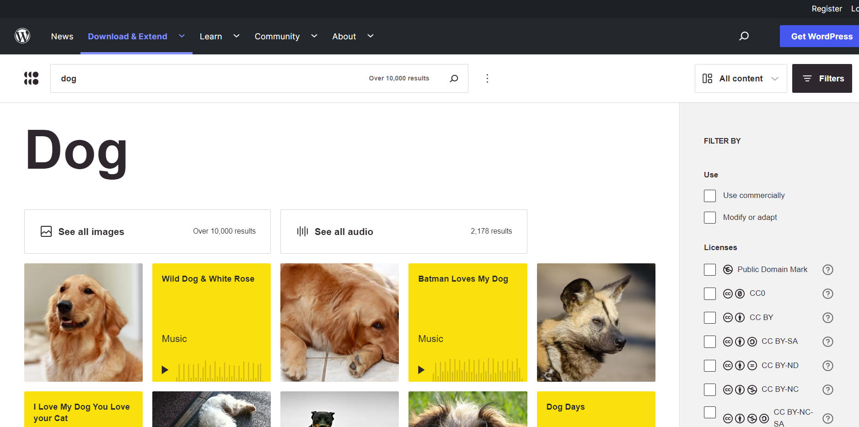

## [Flickr](http://www.flickr.com)

Many of the photographs on flickr have been shared by their authors under the terms of Creative Commons licenses with just a single attribution. To find these images:

* Go to <http://www.flickr.com/>
* Search for the item you are looking for
* Where it says “Any license” click the drop-down menu and select “Modifications Allowed”

Your search results will now include only CC licensed content you can use.

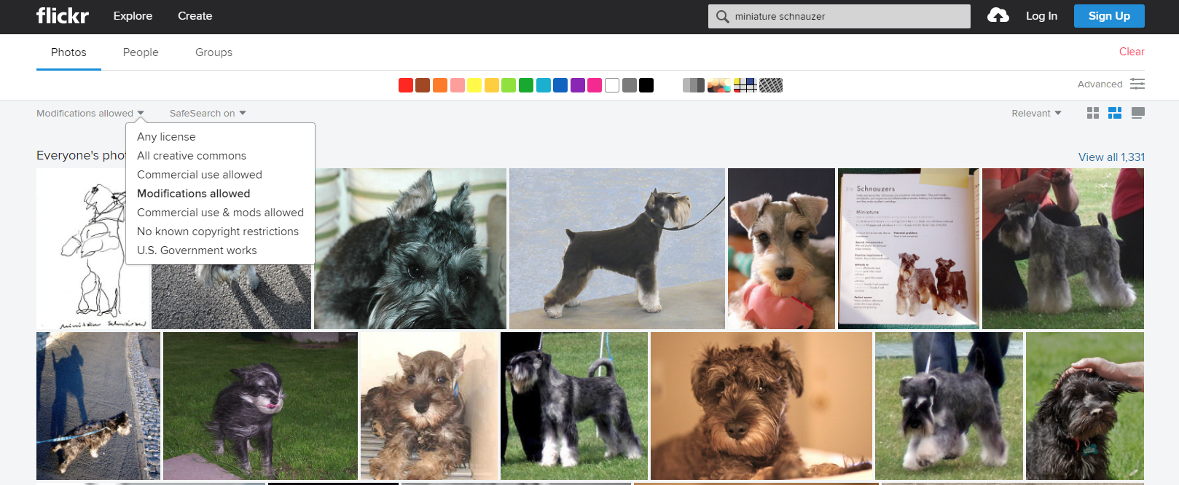

## [**Wikimedia Commons**](http://commons.wikimedia.org/)

Wikimedia Commons hosts all of the images that can be found on Wikipedia. As an openly licensed resource all of the images are made available under a Creative Commons license or exist in the public domain. This site is great for finding images concerning everything from scientific processes to actors to emojis. To find these images:

* Go to <http://commons.wikimedia.org>
* Search for the item you are looking for
* All results will be content you can use

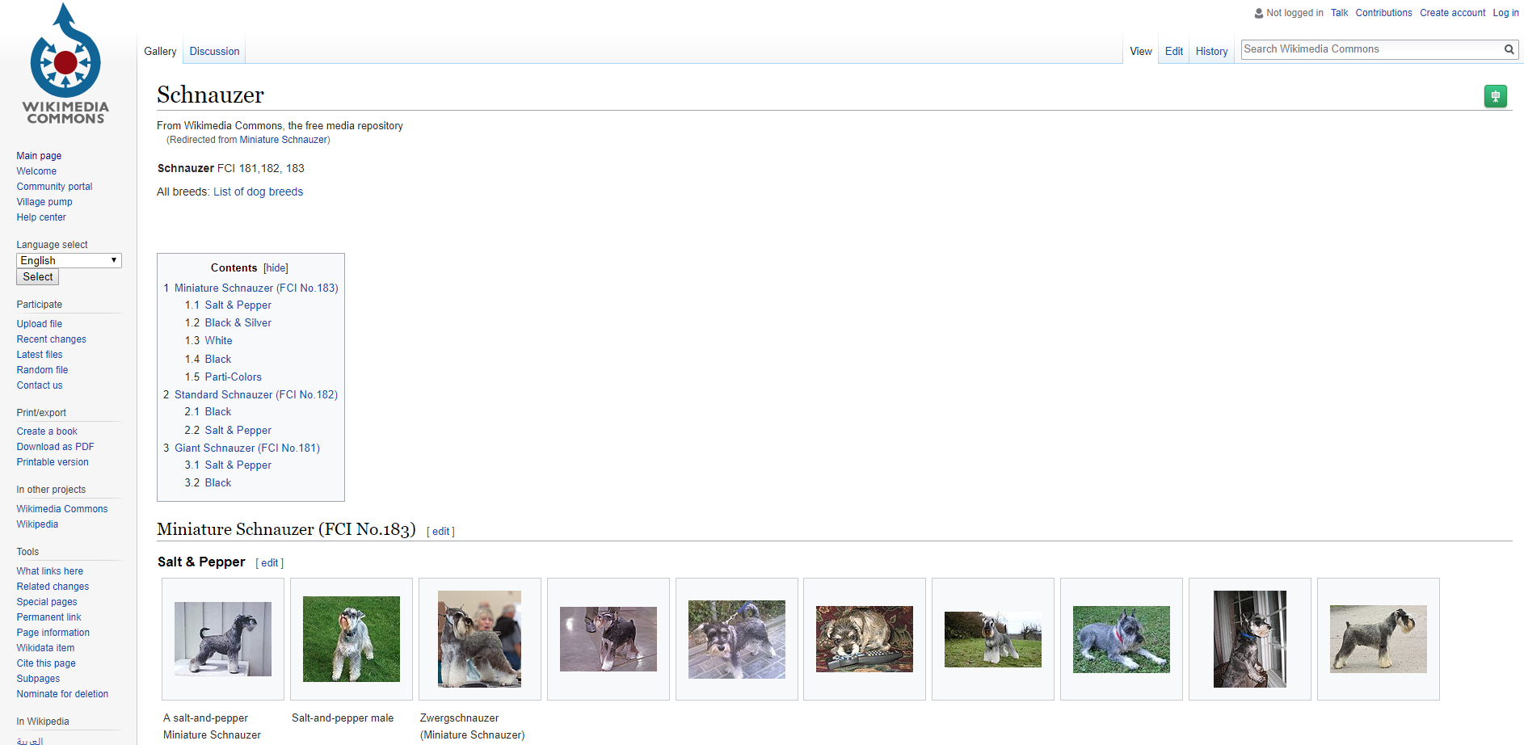

## [**Google Image Search**](https://images.google.com/)

The Google Image Search feature can be customized for finding openly licensed images. To find these images:

* Go to <https://images.google.com/>
* Search for the material you want
* Click Tools
* Under “Usage Rights” select “Creative Commons Licenses” in the drop down menu, then your searches will yield openly licensed images.

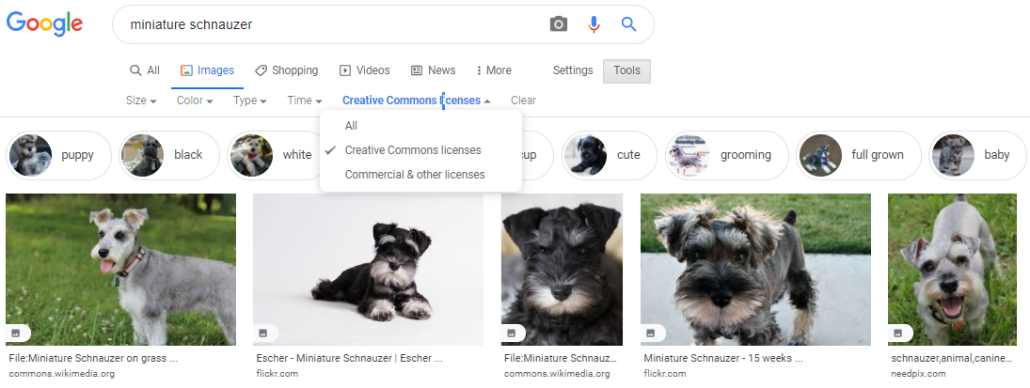

## [Pexels](https://www.pexels.com)

Pexels is a well-designed and user-friendly stock photo and video library containing a variety of high-quality, professional materials. Pexels has its own license, which allows use and even modification without attribution. However, it places some additional restrictions: identifiable people should not be depicted in a bad light, and use should not imply endorsement by people or brands that may be included in the imagery, in addition to the usual restrictions on resale and redistribution.

* Go to <https://www.pexels.com>
* Search for the material you want
* All results will show up—be aware of ads, which are laid out as smaller thumbnails in a 2x2 grid. In the below screenshot, two cut off ads at the bottom center

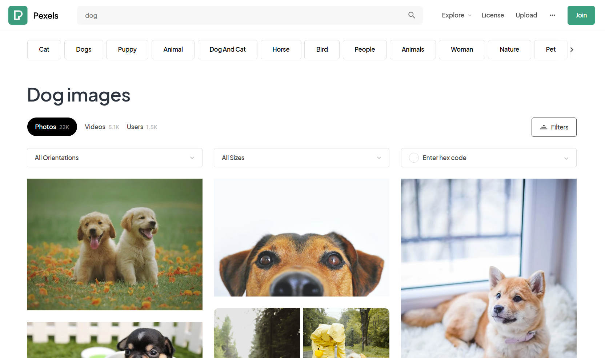

## [Everypixel](https://www.everypixel.com/)

Everypixel is a stock search engine that indexes 50 agencies. It contains a mix of free and paid works, so make sure to toggle the drop down to **Free only** before you perform any search (it defaults to **Free & paid**). Sponsored options are interspersed with all results, but are highlighted in their own section. Photos can eventually be downloaded from the underlying indexed site (such as Unsplash).

* Go to <https://www.everypixel.com/>
* Toggle the dropdown that reads **Free & paid** to select **Free only**
* Search for the item you are looking for

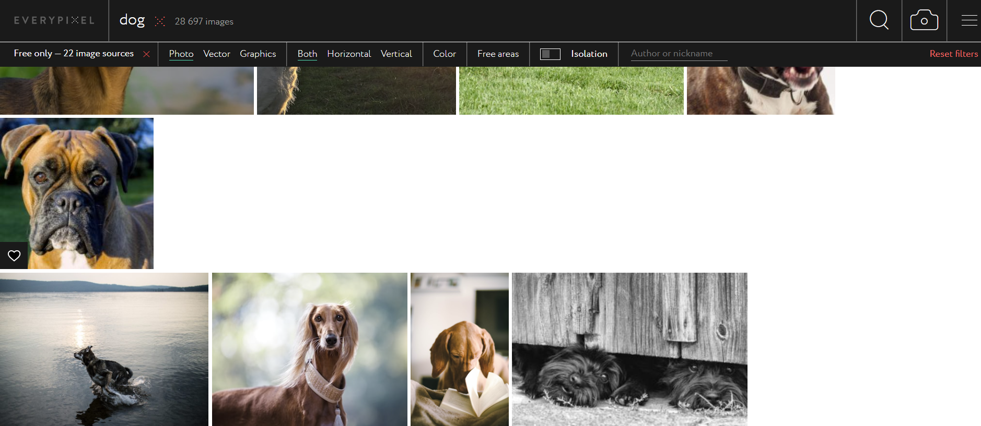

## Freepik

Freepik is an image bank that offers paid and premium materials. Variety is its forte—images include photos, illustrations, vectors, and other graphic design elements. Make sure to use the drop down to restrict your search to **Free** works. If you do not narrow your search, a crown icon indicates Premium items interspersed in the results. Attribution is required.

* Go to <https://www.freepik.com>
* Toggle the dropdown that reads **Images** to select the **Free** square checkbox
* Search for the item you are looking for

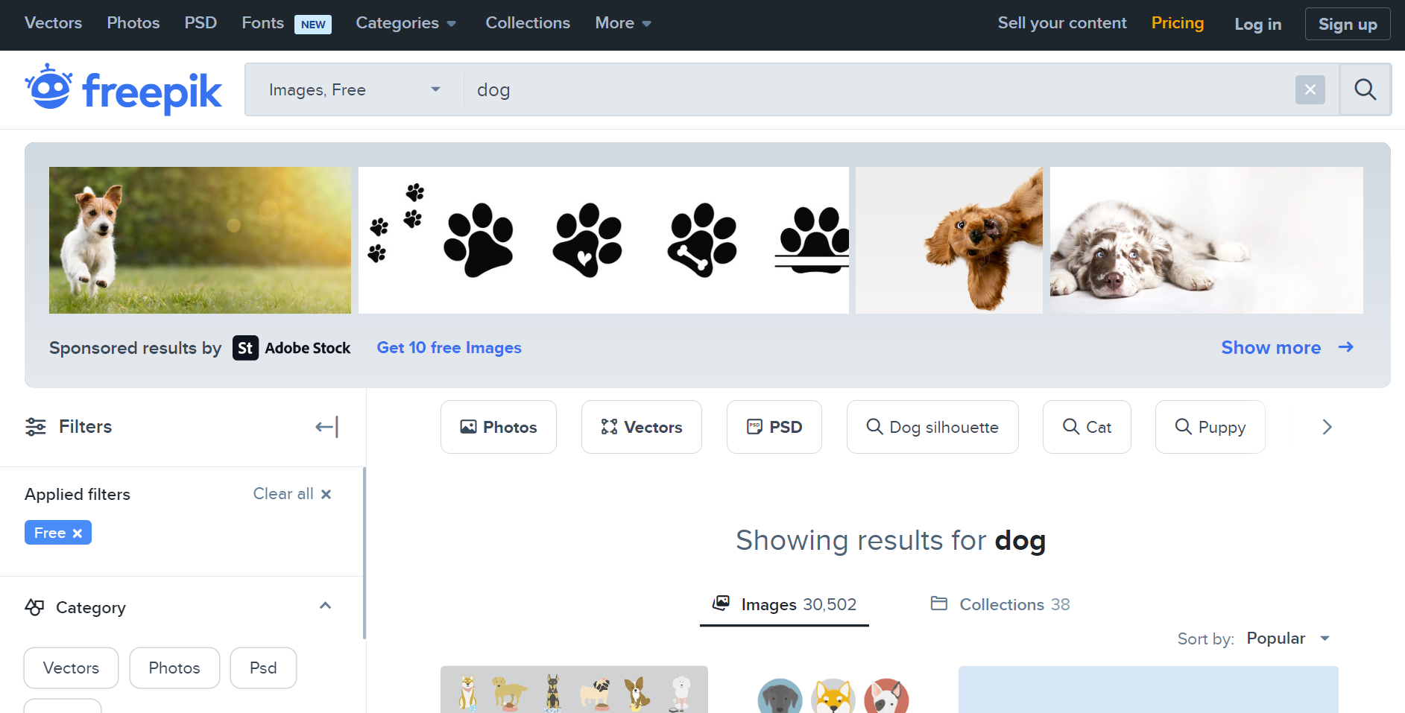

## [Stock Up](https://stockup.sitebuilderreport.com/)

Stock Up contains >25k images, mostly CC and some public domain. It indexes photos from about 30 different sites. Searching for anything in Stock Up will retrieve results across different sites. Hover over a result to check where the photo is from. Clicking on a result takes you directly to the link on the underlying indexed site, where you can download the image and read more detailed license information.

* Go to <https://stockup.sitebuilderreport.com/>
* Search for the item you are looking for
* All results from indexed sites will appear in a grid, and you can click on the results to download from the original source

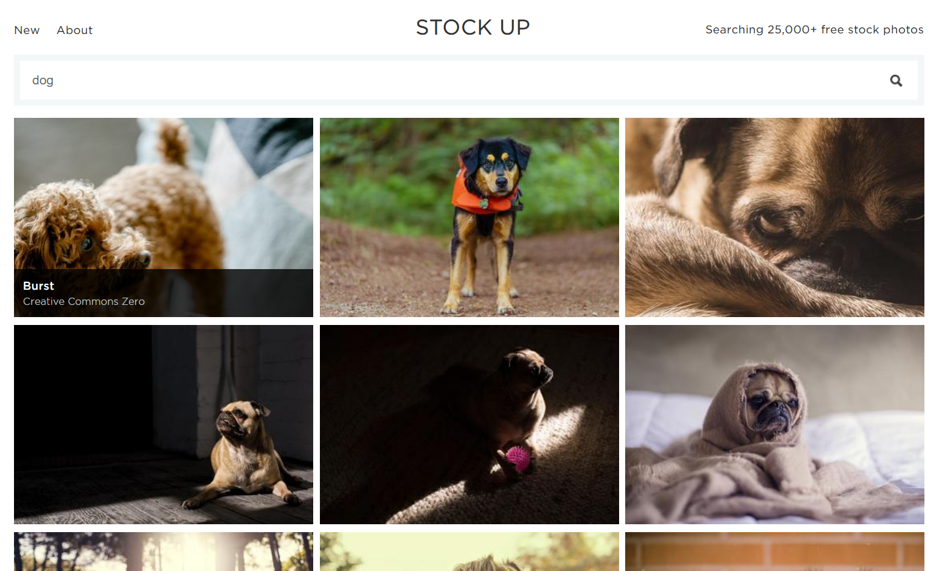

## [Altphotos](http://altphotos.com)

This small (>3k photos) collection contains high-quality CC0 images. The collection is fairly diverse but leans toward more nature and leisure themed offerings.

* Go to altphotos.com
* Search for the item you are looking for
* All results will appear

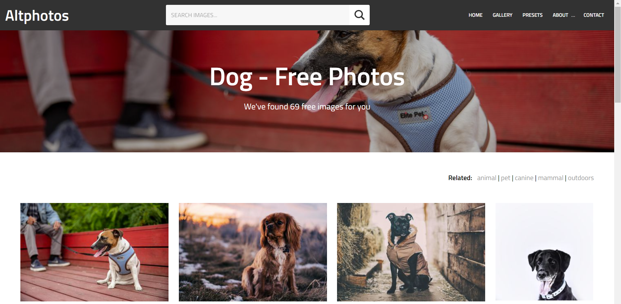

# Icons & Emojis

## [**The Noun Project**](http://thenounproject.com/)

The Noun Project has a large collection of modern and cleanly styled clip art images that can be used with attribution per the Creative Commons Attribution license. Please make sure you include a link to the icon.

## [Twitter Emojis](https://commons.wikimedia.org/wiki/Category:Twitter_Emoji)

All of Twitter’s emojis are [licensed under a CC BY license](https://twemoji.twitter.com/content/twemoji-twitter/en.html), meaning you can use them in any way you want as long as you credit them back to Twitter. Wikimedia has collected nearly all of the 3000 Twitter emojis and has made them easy to browse and find via Google search.

## Freepik

Freepik is an image bank that offers paid and premium materials. Make sure to use the drop down to restrict your search to **Free** works and **Icons**. Attribution is required for all icons.

## [Iconmonstr](https://iconmonstr.com/)

Iconmonstr is a growing collection of 4500+ free monocolor vectors that can be used without attribution. Icon colors can be changed before downloading.

# Books & Textbooks

Open textbooks are textbooks that are made available under the terms of a Creative Commons license. The books can be downloaded as PDFs (and other digital formats) and used as you need them in your project. Hard copies of the books can be purchased through print-on-demand services for a small fee. A few of our favorite open textbook libraries are [**Openstax CNX**](http://www.cnx.org/) , [**College Open Textbooks**](http://www.collegeopentextbooks.org/) , and [**Open Textbook Library**](http://open.umn.edu/opentextbooks/) .

## [HathiTrust Digital Library](http://www.hathitrust.org/)

HathiTrust contains over 6.5 million open access and public domain books, journals, federal and state government documents, and dissertations scanned from the shelves of North American research university libraries.

* Go to [www.hathitrust.org](http://www.hathitrust.org/)
* Search for your subject matter or title using the Catalog search
* Look for items that say “Full View”
* Under "About this Book" verify that the rights information says public domain or Creative Commons license
* Download a full pdf by logging in with your U-M uniquename

# Journal Articles

There are many Open Access Journals covering all academic disciplines. Your [U-M Library subject specialist](https://www.lib.umich.edu/subject-specialists) can help you identify Open Access Journals and readings that can be used for your project, including being used in an online course or other learning experience.

## [Directory of Open Access Journals (DOAJ)](https://doaj.org/)

DOAJ is an online directory that indexes and provides access to quality open access, peer reviewed journals. It allows you to browse and search within your area of interest for articles that can be made available to learners.

# Video

## [**Youtube**](http://youtube.com)

*Some* videos on Youtube have been given an open license by their respective authors. You are free to include and adapt these videos, with attribution. To find these videos:

* Go to <http://youtube.com> and perform a search
* Click “Filter” and under “Features” select “Creative Commons”

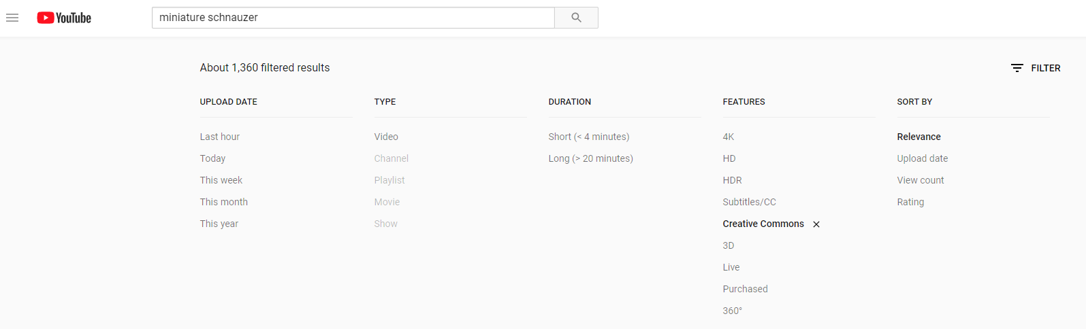

## [Vimeo](http://vimeo.com)

*Some* videos on Vimeo have been given an open license by their respective authors. Depending on the license, you are free to include and adapt these videos, with attribution. To find these videos:

* Go to <http://vimeo.com> and perform a search
* On the left side of the page under “License” you can check each of the license categories we can use:
  + CC BY
  + CC BY-NC-SA
  + CC BY-NC

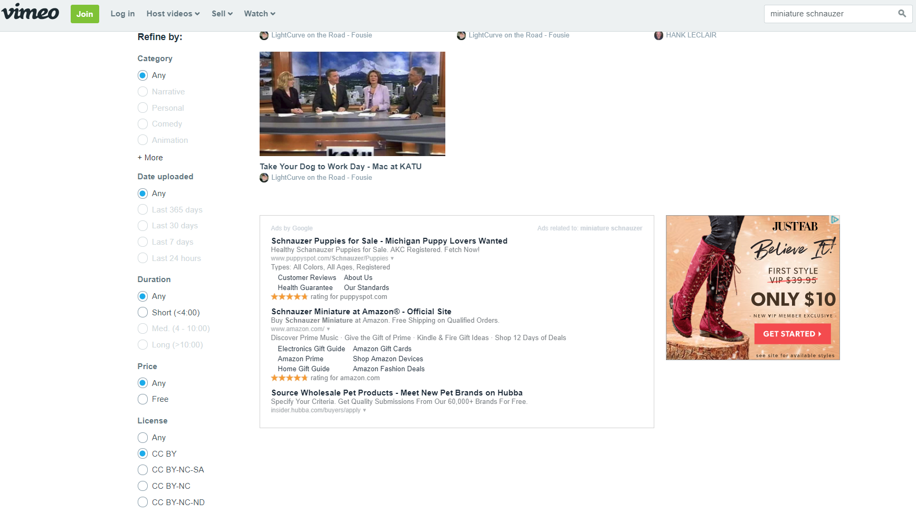

## [Mazwai](https://mazwai.com/)

A collection of stock video footage that’s all available under a CC BY 3.0 license (requiring attribution only) or the open Mazwai license (allowing all uses with no attribution, as long as the clips aren’t distributed on their own).

## [Pexels](https://www.pexels.com/videos/)

Pexels is a well-designed and user-friendly stock photo and video library containing a variety of high-quality, professional materials. Pexels has its own license, which allows use and even modification without attribution. However, it places some additional restrictions: identifiable people should not be depicted in a bad light, and use should not imply endorsement by people or brands that may be included in the imagery, in addition to the usual restrictions on resale and redistribution.

# Audio

## [CC Mixter](http://ccmixter.org/)

A library of openly licensed songs and soundtracks for videos, podcasts, and commercial projects.

## [Freesound](http://www.freesound.org/)

A selection of openly licensed sound effects.

## [**MusOpen**](http://www.musopen.com/)

Provides recordings, sheet music, and textbooks to the public for free, without copyright restrictions.

## [Free Music Archive](http://freemusicarchive.org/)

Provides curated CC licensed music of all genres.

## [Openverse](https://wordpress.org/openverse/)

This robust index searches through >600 million images and audio from various collections. All content is licensed under CC or public domain. Filter options for audio enable granular selection of audio category (e.g., news, sound effects, music), extension (e.g., MP3, FLAC), and particular types of licenses (e.g., only CC BY-SA). Because Openverse indexes from various sources, quality variations are expected.

# Musical Scores

## [International Music Score Library Project ("IMSLP")](https://imslp.org/wiki/Main_Page)

IMSLP offers over half a million free musical scores licensed under [CC BY-SA 4.0](https://creativecommons.org/licenses/by-sa/4.0/). Within scores, you can search the categories below. Remember to attribute the copyright holder in order to comply with the CC license terms.

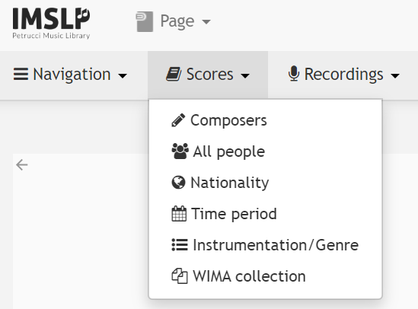

## [**Mutopia Project**](https://www.mutopiaproject.org/)

Mutopia Project offers exclusively public domain and CC-licensed sheet music for download and use. Mutopia can be searched using the homepage shortcuts or the advanced search box shown below.

